SPORTS ANALYTICS · PORTFOLIO PROJECT
Football Expected Goals (xG)
Prediction Model
Final project insights, findings and visualisations

This report combines the project findings summarised from the notebook with the eight graph screenshots supplied for this document. Each graph is reproduced and followed by an interpretation. Descriptions are grounded in what is visible in the screenshots and the previously reported notebook results.

6,347  shots after cleaning (6,619 raw) | 5  international tournaments | 1,430  test shots (World Cup 2022) | 152  goals in the held-out test set

1. Executive Summary
- The project explores Expected Goals (xG), a probability estimate for whether a football shot will result in a goal, using StatsBomb event data.
- The reported dataset contains 6,619 shots before cleaning and 6,347 after cleaning across five international tournaments.
- The modelling workflow compares a Logistic Regression baseline and an XGBoost model with StatsBomb’s supplied xG estimates.
- The held-out test tournament is the 2022 FIFA World Cup. The reported test set contains 1,430 shots and 152 goals.
- The reported XGBoost results slightly improve on Logistic Regression, while StatsBomb’s xG benchmark performs better on the reported Log Loss, Brier Score and ROC-AUC metrics.
- The visualisations show that shot distance and location are strongly associated with scoring probability, and that most shots receive low xG values.

2. Dataset and Preprocessing
The notebook uses StatsBomb Open Data, accessed with StatsBombPy. The competitions listed in the notebook summary are the 2018 FIFA World Cup, UEFA Euro 2020, Copa América 2024, UEFA Euro 2024, and the 2022 FIFA World Cup.
The notebook excludes penalty shots and attempts from period 5 (penalty shootouts). The target variable is a binary goal indicator: 1 when the shot outcome is Goal, otherwise 0. StatsBomb’s shot_statsbomb_xg is used as a benchmark prediction, not as the target variable.
Data source: https://github.com/statsbomb/open-data

3. Features and Models

Baseline features
- distance — calculated from shot coordinates to the centre of goal.
- angle — a derived shooting-angle feature.
- is_header — indicates whether the shot was taken with the head.

Additional XGBoost pass-context features
- has_key_pass, from_cross, from_through, from_cutback and from_switch.
- key_pass_length.
- pass_high and pass_ground.

NOTE
The notebook also contains code for freeze-frame features such as nearby defenders and goalkeeper position, but the reported final model does not use them because the freeze-frame collection is empty.

Models compared
- Logistic Regression — a baseline probability model using distance, angle and header indicator.
- XGBoost — a gradient-boosted tree model using the three base features and eight pass-context features.
- StatsBomb xG — the benchmark probabilities supplied with the event data.

4. Graphs and Key Insights

Figure 1. Goal rate by shot distance
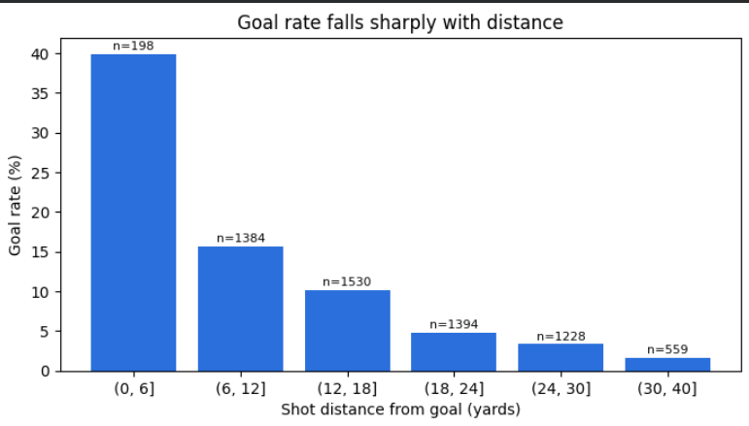
Observed goal rate by distance bucket (n = shots per bucket)
INSIGHT
The observed goal rate falls sharply as shot distance increases. The closest distance bucket has a goal rate of about 40%, while the 30–40 bucket is below 2%. The counts above the bars show the number of shots in each bucket. This supports distance as an important factor in shot-scoring probability. Note: the screenshot labels distance in yards, while the notebook’s calculation was described as StatsBomb coordinate units; confirm the conversion before calling these values yards.

Figure 2. Shot map: goals vs non-goals
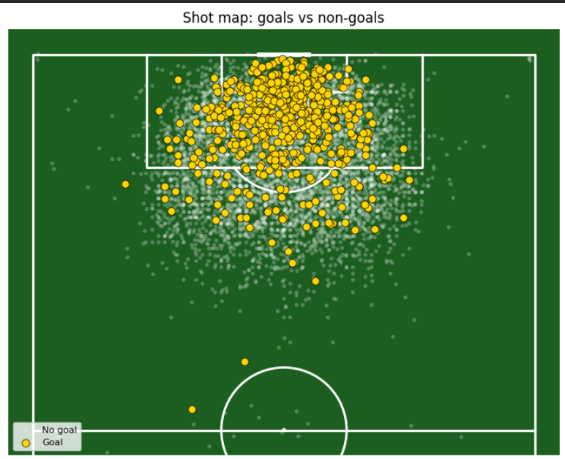
Half-pitch shot map: goals (yellow) and non-goals (grey)
INSIGHT
The shot map shows shots across the attacking half, with goals highlighted in yellow and non-goals in grey. Goals cluster more heavily in and around the penalty area, while many shots from farther away do not result in goals. This illustrates the importance of shot location, but location alone does not capture all factors that affect a shot’s probability.

Figure 3. StatsBomb xG against distance and shooting angle
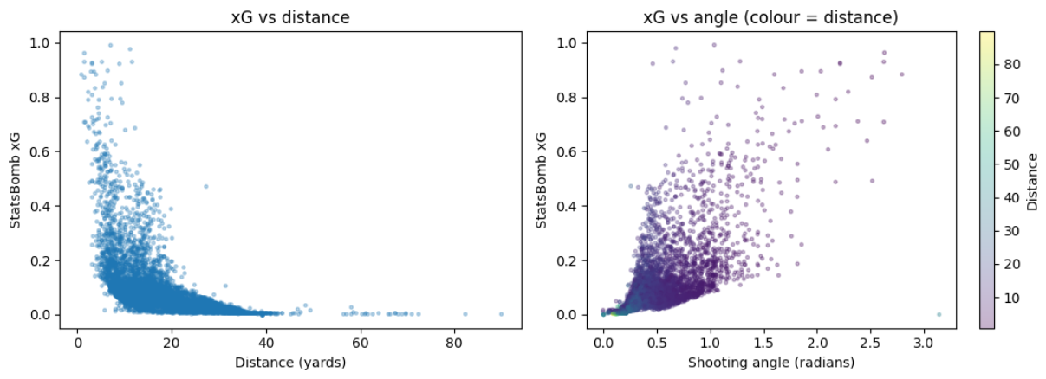
StatsBomb xG vs distance (left) and vs shooting angle (right)
INSIGHT
The left panel shows that StatsBomb xG generally declines as shot distance increases. Most distant shots have very low xG, while high xG values occur mainly closer to goal. The right panel shows that xG tends to be higher at larger shooting angles, although the points are widely spread: distance and angle are useful predictors, but they do not fully explain shot quality.

Figure 4. Calibration and predicted xG distributions
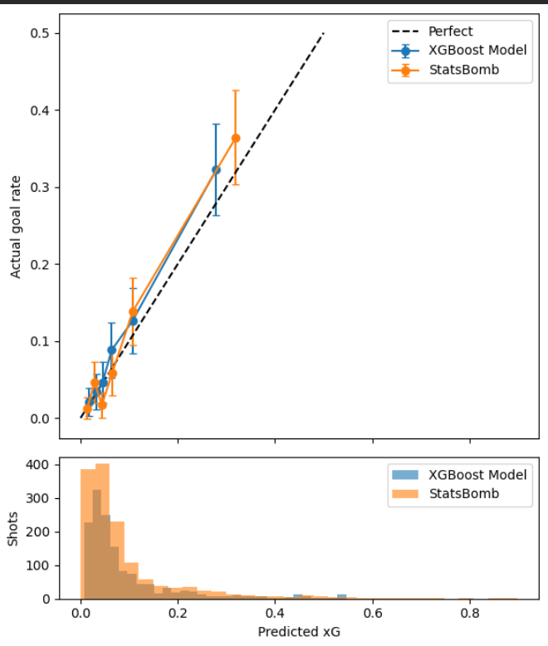
Calibration curves with error bars, and predicted-xG histogram
INSIGHT
The upper panel compares actual goal rates with predicted probabilities for XGBoost and StatsBomb, alongside a perfect-calibration reference. Points close to the dashed diagonal indicate better calibration; points above it indicate observed scoring exceeds predicted probability, while points below it indicate overprediction. Error bars indicate uncertainty in the observed rates. The lower histogram shows that most shots receive low xG values, with a smaller number assigned higher probabilities. Interpret calibration cautiously where bins contain few shots.

Figure 5. Actual goal rate vs predicted xG by distance
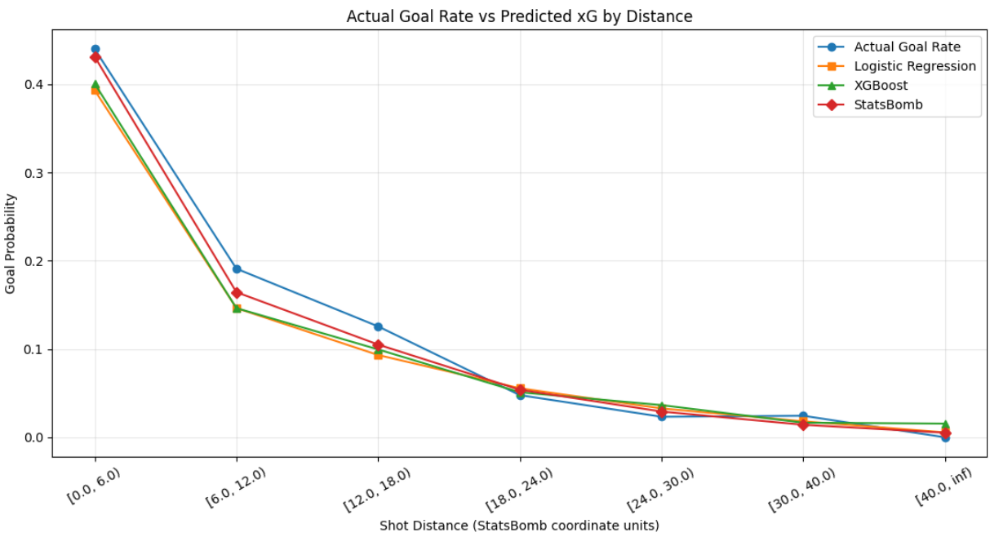
Actual goal rate and mean predicted xG by distance bucket
INSIGHT
The actual goal rate and all three models’ average predictions decline with distance. The model curves are relatively close at longer distances, while differences are more visible in the nearest buckets. In several buckets the actual rate is above the predicted values, but the observed rate is noisy and depends on the number and type of shots in each bucket. This plot helps assess whether the predicted probabilities track the empirical pattern.

Figure 6. Distribution of predicted xG values
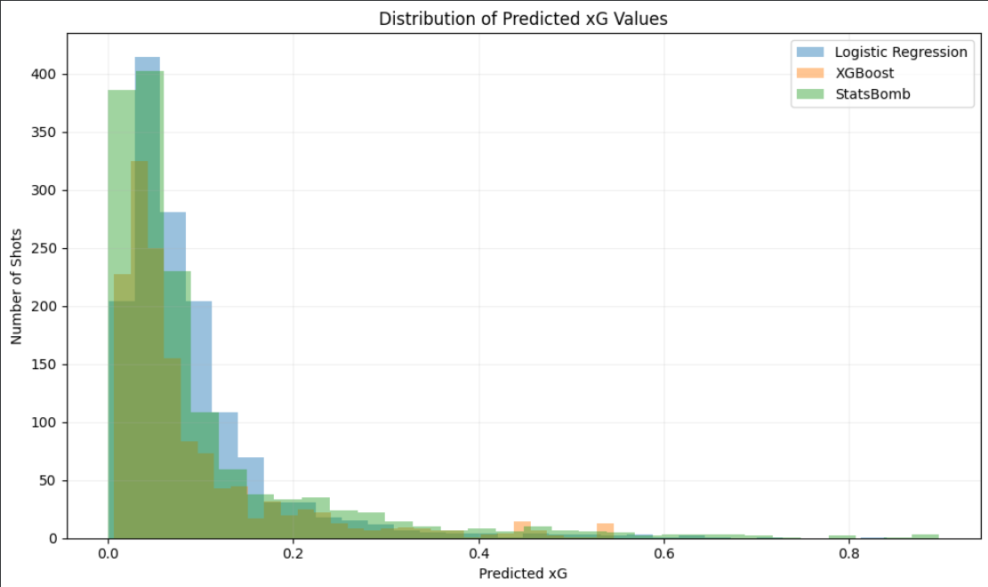
Distribution of predicted xG for the three models
INSIGHT
All three distributions are concentrated at low probabilities, which is expected because most shots do not become goals. The distributions have long right tails, representing a small number of high-quality chances. The shape and tail differ by model, so this plot should be read together with calibration and scoring metrics rather than used alone to choose a winner.

Figure 7. Predicted xG by shot location — World Cup 2022
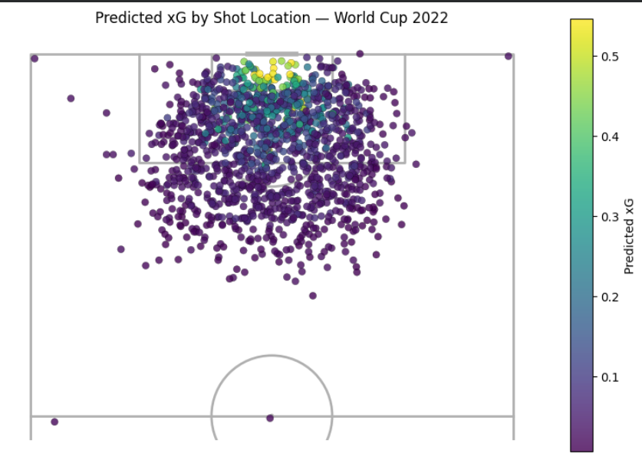
XGBoost predicted xG for each World Cup 2022 shot, by location
INSIGHT
Each point represents a World Cup 2022 shot. The colour encodes the XGBoost predicted xG, with brighter points indicating higher estimated scoring probability. High predicted values are concentrated near the goal, while shots from farther away generally receive low probabilities. This is a map of observed shot locations, not a continuous xG surface over every pitch location.

Figure 8. Actual goals vs predicted xG by tournament
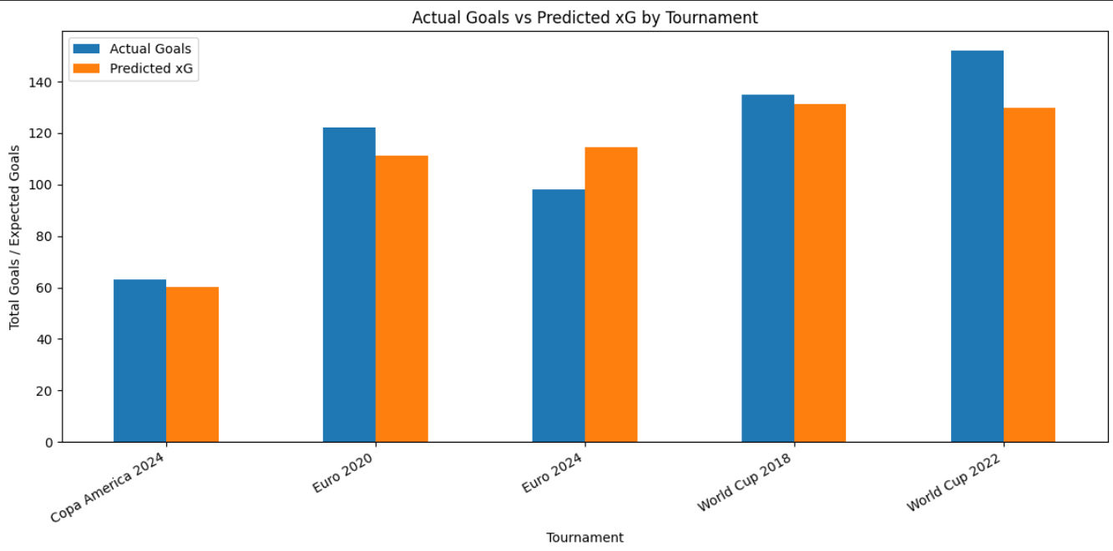
Actual goals vs summed predicted xG, per tournament
INSIGHT
The chart compares actual goals with summed predicted xG across tournaments. Predictions are close to actual totals in some tournaments, while the gap is larger in others. For World Cup 2022, actual goals are higher than the displayed predicted xG total. Aggregate differences in one tournament do not alone prove systematic model bias; predictions should also be evaluated at shot level using metrics such as Log Loss, Brier Score and ROC-AUC. Verify the tournament label ‘Euro 2018’ in the screenshot because it may not match the tournament list described in the notebook.

5. Reported Model Evaluation
The following metrics were reported in the notebook summary for the World Cup 2022 test set:
Model | Log Loss ↓ | Brier Score ↓ | ROC-AUC ↑
Logistic Regression | 0.2896 | Not reported | 0.7796
XGBoost | 0.2859 | 0.0823 | 0.7831
StatsBomb xG | 0.2665 | 0.0762 | 0.8148

- Log Loss: lower values indicate better probabilistic predictions.
- Brier Score: lower values indicate lower squared error between predicted probabilities and outcomes.
- ROC-AUC: higher values indicate stronger ability to rank goal shots above non-goal shots.

6. Calibration and Hyperparameter Tuning

Calibration results reported
Variant | Log Loss | Brier Score | ROC-AUC | Summed xG
Raw XGBoost | 0.2859 | 0.0823 | 0.7831 | ≈130
Sigmoid calibrated | 0.2927 | 0.0835 | 0.7846 | ≈130
Isotonic calibrated | 0.3073 | 0.0824 | 0.7829 | ≈133
StatsBomb xG | 0.2665 | 0.0762 | 0.8148 | 137.88

Among the reported XGBoost variants, raw XGBoost has the best Log Loss and Brier Score. Sigmoid calibration has slightly higher ROC-AUC but worse Log Loss and Brier Score. StatsBomb scores best on all three reported metrics.

Hyperparameter tuning caveat
CHECK BEFORE PRESENTING
The notebook summary reports GroupKFold tuning by tournament. In the displayed grid results, max_depth=2 and learning_rate=0.02 has the lowest reported CV Log Loss (0.2542). However, the notebook prose reportedly gives a different best value, and the final model uses max_depth=3 with learning_rate=0.03. Recheck the notebook output and narrative before presenting the tuning result as definitive.

7. Overall Findings
- Shot distance has a strong inverse relationship with observed goal rate and StatsBomb xG.
- Shots and goals are concentrated in and around the penalty area; distant attempts are less likely to score.
- The angle plot suggests that wider shooting angles can be associated with higher xG, but there is substantial variation at similar angles.
- Most predicted xG values are low, with a small number of high-probability chances.
- XGBoost slightly outperforms Logistic Regression on the reported Log Loss and ROC-AUC values.
- StatsBomb xG is the strongest of the three on the reported held-out test metrics.
- Summed xG need not equal actual goals for a tournament. A gap is normal for a probabilistic estimate and should be interpreted alongside shot-level metrics.

8. Limitations and Items to Verify
- The distance formula in the notebook was described as using StatsBomb coordinate units. The first screenshot labels distance in yards. Confirm that a coordinate conversion was applied before describing the buckets as yards.
- The tournament chart screenshot contains the label ‘Euro 2018’, while the notebook summary lists Euro 2020 and Euro 2024. Verify the label and underlying tournament data.
- The reported hyperparameter tuning table and accompanying prose are inconsistent; verify the best parameters and final model settings.
- The final XGBoost model does not use freeze-frame defender/goalkeeper features in the reported version.
- Results are based on the tournaments and split used in this notebook and may not generalise directly to club or league football.

9. Future Improvements
- Use verified coordinate conversion and document units clearly.
- Add defensive pressure, goalkeeper position and nearby defender features when reliable freeze-frame data is available.
- Validate across more held-out tournaments or use tournament-grouped cross-validation.
- Reconcile hyperparameter tuning outputs with the final model configuration.
- Investigate feature importance and permutation importance on held-out data.
- Build an interactive shot map or dashboard for football analysts.

10. Conclusion
SUMMARY
This project demonstrates a football analytics workflow that combines event data collection, preprocessing, feature engineering, visual exploration, probabilistic modelling and evaluation. The graphs show that shot distance and location are strongly related to scoring probability. The custom XGBoost model slightly improves on the Logistic Regression baseline, but StatsBomb’s benchmark xG estimates perform best on the reported held-out test metrics. The project can be strengthened by verifying units and tournament labels, resolving the tuning inconsistency, and incorporating richer contextual features.

